DETACH : Distributed Data-Aware Scheduling for Hadoop

Akash Rafaliya, Chintan Patel, Arpit Sheth, Ke Wang, Ioan Raicu
Department of Computer Science,
Illinois Institute of Technology,
Chicago, IL
arafaliy@hawk.iit.edu, cpatel35@hawk.iit.edu, asheth13@hawk.iit.edu, kwang22@iit.edu, iraicu@iit.edu

Abstract— Nowadays, for processing a large amount of data Hadoop is one of the widely used frameworks. Hadoop scheduler has a significant effect on Hadoop performance. However, one of the primary concerns with Hadoop scheduler is its centralized architecture, which will prevent Hadoop from scaling to larger scales towards tomorrow's extreme-scale systems. MATRIX is a distributed scheduler for fine-grained data-intensive MTC applications, which will replace the Hadoop scheduler and enable distributed data-aware scheduling of data-intensive Hadoop applications. MATRIX has already outperformed on Falkon, Sparrow, and CloudKon. MATRIX has shown good result on the swift workflow engine. We have designed the architecture of the system that allow MATRIX talks to the YARN resource manager, the Hadoop - Map Reduce Application Master, and the HDFS file system. We believe that this will reduce the bottleneck of Hadoop scheduler and improve scalability and efficiency of Hadoop. Also, we have done that benchmarking for Hadoop, MATRIX, Swift (Workflow scripting language) and Charm++ to show their difference in terms of throughput.
Keywords: Hadoop, MATRIX, Scheduling, YARN, Many-task computing, Map Reduce

Background Information
The primary goal of Hadoop[1][3][10] is to enable distributed processing of large data sets in a distributed computing environment. But with the dramatic increase in the scales of today's distributed systems, it is required to develop efficient job scheduler for Hadoop.
Hadoop is an open-source implementation of the MapReduce paradigm provided by Apache Software Foundation. Hadoop consists of Hadoop Distributed File System (HDFS) and MapReduce. The Hadoop MapReduce framework in earlier (1.x) Hadoop [1][3] releases has a single master service called a JobTracker and several slave services called TaskTrackers, one per node in the cluster. When we submit a MapReduce job to the JobTracker, the job is placed into a queue and then runs according to the scheduling rules defined by an administrator. Here, Job Tracker manages the assignment of map-reduce tasks to the Task Trackers. With Hadoop 2.x, Apache introduced a new resource management system called YARN[5] (Yet Another Resource Manager) which provides generic scheduling and resource management services. YARN architecture and the components, along with communication among them are shown in Figure-1. There are three main components of YARN, Central Resource Manager, per node Node Manager and per application Application Master. The core component of YARN is the Resource Manager, a dedicated resource scheduler that assigns resources to requesting applications. The primary tasks of YARN are to maintain a global view of all resources in the cluster, handling resource requests, scheduling the request, and then assigning resources to the requesting application. HDFS lives on top of the file systems that are installed on all individual computers that make up the Hadoop cluster, which provides a distributed architecture for extremely large scale storage, which can easily be extended by scaling out.
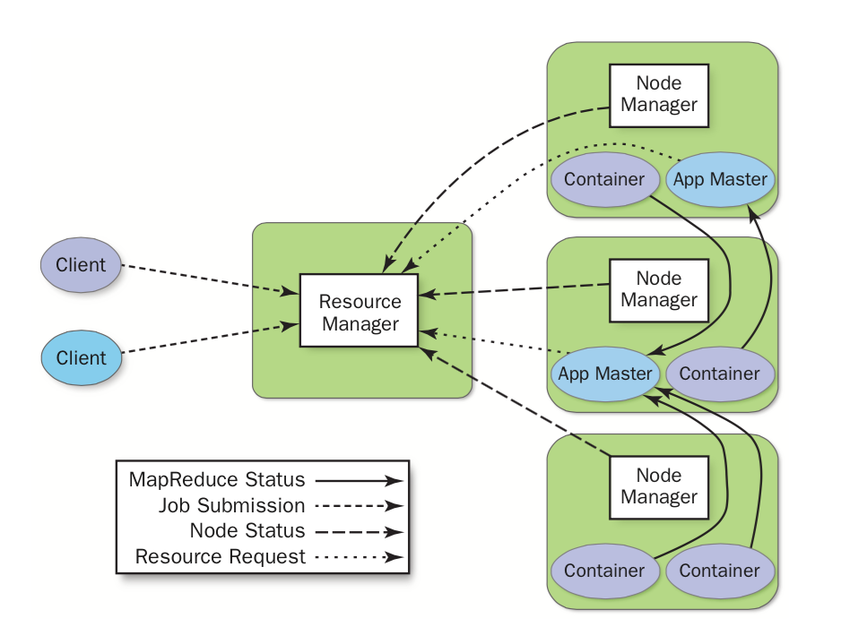
Figure 2: Hadoop-YARN Architecture

MATRIX [2-x] is a fully distributed task scheduling system for fine-grained data-intensive MTC applications, which utilizes work stealing to achieve distributed load balancing, and a distributed key-value store to manage task metadata. MATRIX is developed in C++. MATRIX has 3K lines of codes, with 8K lines of ZHT codebase. MATRIX architecture is shown in Figure 2. In MATRIX, all schedulers are fully connected with each other at the node level. And executors keeps executing task provided by schedulers. If any node scheduler has no more function to perform then it will start stealing jobs from neighbors and give its executor to execute it. The execution unit of MATRIX follows the queue structure to handle tasks and support schedulers for work stealing whenever require. MATRIX scheduler needs ZHT client APTs to update necessary information related to the client.
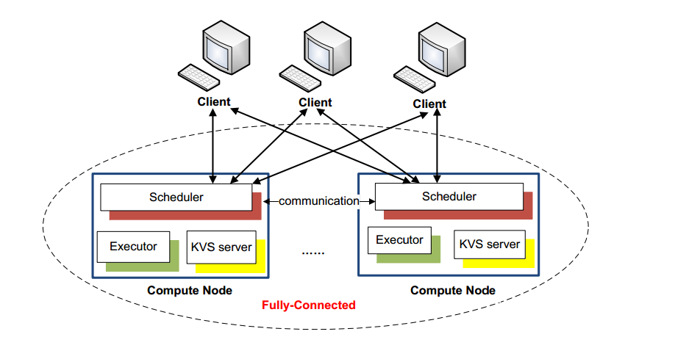Figure 2: MATRIX architecture

problem statement
MapReduce is one of the modern large-scale data-driven programming models. Hadoop implementation and framework decoupling have allowed MapReduce to scale to tens of thousands of commodity cluster processors but the centralized designs of the resource manager, task scheduler and metadata management of HDFS file system adversely prevent Hadoop from scaling to larger scales towards tomorrow's extreme-scale systems. Our aim is to integrate MATRIX scheduling system to Hadoop framework. MATRIX utilizes work stealing to achieve distributed load balancing, and a distributed key-value store to manage task metadata. MATRIX will replace the Hadoop scheduler and enable distributed data-aware scheduling of data-intensive Hadoop applications, which will make Hadoop more scalable and efficient. This work will build the interfaces that allow MATRIX talks to the YARN resource manager, the Hadoop application manager, and the HDFS file system. A distributed key-value store (ZHT) will be used to keep the task metadata in a distributed and scalable way.

proposed solution
The goal of this work is to design distributed data-aware scheduler for Hadoop – MapReduce. We aim to integrate Hadoop with MATRIX to make Hadoop more scalable. Because of data-aware work stealing approach, this solution will utilize Hadoop MapReduce tasks equally over the cluster and make Hadoop more efficient to handle data-intensive application.
Figure-3 describes how the job is launched in Hadoop-YARN. Here user submits app request to Resource Manager, then RM allocates container to Application Manager which is in RM. Then Application Manager bootstrap Application Master to manager application execution. Application Master register with RM and then communicate with Node Manager about allocated containers. During execution Application, Master reports status and completion of the application to Resource Manager.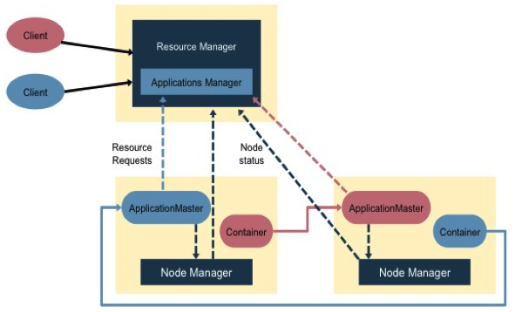
Figure-3: Lifecycle of YARN job execution

Hadoop Integration with MATRIX:
Hadoop has a centralized approach to handling resource management and jobs scheduling. YARN[5] is responsible for handling MapReduce tasks over the cluster in Hadoop 2.x, which is better than its previous approach in Hadoop 1.x. In a current version of Hadoop, YARN has two main part Resource Manager and Application Manager. Resource Manager is responsible for maintaining metadata of available resources of the cluster. After submission of MapReduce job to Resource Manager, it starts Application manager. Application manager decides number of MapReduce tasks based on input data. Based on number of tasks application manager send a request to the resource manager to provide available resources to run MapReduce jobs. In this approach, each node has to communicate with resource manager and application manager. Whenever computing nodes get task this situation create network overhead and create bottleneck over the system.
Our solution is to use MATRIX as a middle layer to allocate tasks to Node Manager. As Shown in Figure-4, in this approach each compute node runs a scheduler, Node Manager, Executor and ZHT server. In this system, MATRIX works at a node level, so it communicates with Application Master and also among them. Application Master provides tasks among few MATRIX schedulers. Scheduler gives the job to specific execution unit attached to it. And as per the MATRIX execution unit design, containers have queue structure for task execution process. Here all the schedulers are fully connected and with each one knowing each other. Executor keeps executing tasks from the scheduler. When scheduler has no more tasks it enables work stealing technique and starts steal tasks from neighbors that have more task in wait queue of the execution unit. Here scheduler works as a ZHT client to update information of task status to store in ZHT. ZHT is used to keep the tasks metadata in distributed, scalable, and fault tolerant way.
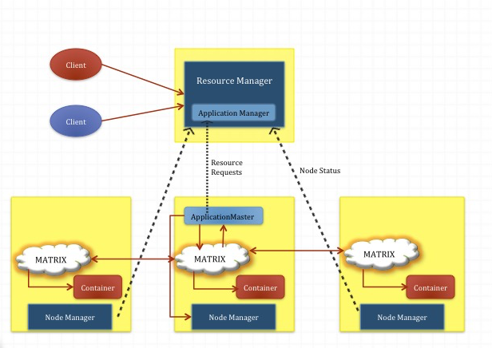
Figure - 4: DETACH system Architecture

Evaluation
This section analyzes all the experimental results including evaluation matrices performed on MATRIX, Hadoop, Swift and Charm++ in terms of their Throughput and Latency. To show how our system can improve performance of Hadoop-YARN.

- Testbed
We run all four systems on Amazon EC2. We have used c3.large instance on Amazon EC2. It had High-Frequency Intel Xeon E5-2680 v2 (Ivy Bridge) Processors with 2-vCPU, 3.75 GB of memory and 2 * 16 GB of SSD storage. We have scaled experiments up to 64 nodes. All of the instances had Linux operation system.

- Metrics
We used two metrics for evaluate these systems – throughput, average task scheduling latency.
- Throughput will show how a fast system can schedule and execute tasks. It will measure the time taken by each read/write operation.
- Average task scheduling latency shows time taken by schedule tasks to different nodes.

- MATRIX Benchmarking
We examine MATRIX in terms of throughput and Total running time on different nodes. Figure 5 shows Running time of MATRIX for 1000 tasks per node for one client. Here, we scale nodes up to 64, and total running time slightly increase from 12 to 15 seconds for 1 to 64 Nodes. After Experimenting MATRIX on single client we do same experiment on 2 clients, total running time is almost same for 1 to 8 nodes. But for large scale of tasks running time increases to 14 seconds for 64 nodes, which is slightly low as shown for one client. This shows Client bottleneck is responsible for slightly increase of running time.

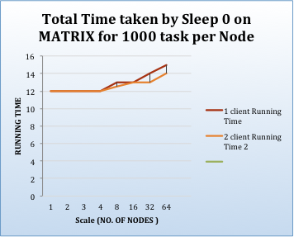
Figure- 5 MATRIX running time

We have calculated throughput for sleep0 on different number of nodes for 1000 task per node. As shown in figure 6, throughput is proportional to no. of node i.e. when we doubled no. of nodes, throughput also increase comparatively.

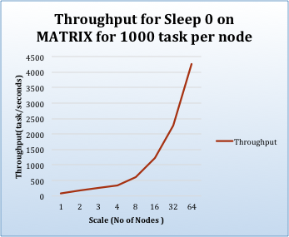
Figure- 6 Throughput

Our experiment is to execute 8000 sleep0 tasks on up to 64 nodes. As per Figure-8, the amount of time to execute 8000 sleep0 tasks is decreasing as we scale no. of nodes i.e. time taken by 8 nodes to run 8000 sleeep0 tasks is approximately 13 seconds which decrease to 3 seconds for 64 nodes for same amount of work. Figure 8 shows throughput for same no of tasks. Throughput increases as no. of nodes increases. This shows using MATRIX we can get good task utilization.
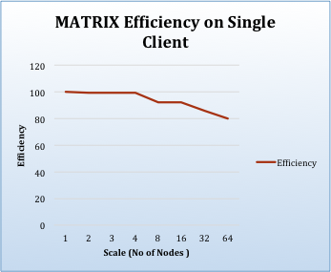
Figure-7 : MATRIX Efficiency on single client

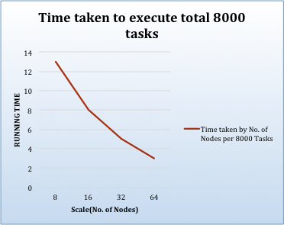
Figure- 7 MATRIX running time for 8000 tasks

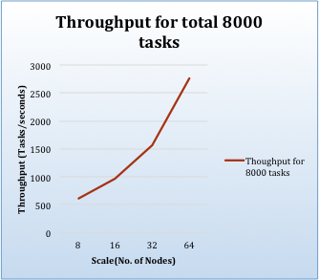
Figure-8 MATRIX throughput for 8000 tasks

- Hadoop-YARN Benchmarking

Figure- 9 shows Hadoop benchmarking on different workloads i.e. WordCount, TeraSort and Sleep task. The workload WordCount counts the occurrence of each words in the input data which is generated using Hadoop Random Text Writer. TeraSort is the TeraGen Program generates a Standard benchmark of large-size data sorting that. For sleep task we use MapReduce technique to schedule sleep task on each node. Here, each map task do sleep0 on based on no. of blocks available in HDFS. For all these workloads we used 10 GB dataset. We compare running time of all three workloads which shows Running time of WorCount is comparatively more than sleep and TeraSort task, which is shown in figure. Additionally, running time between TeraSort and sleep task is almost same because to perform sleep task we use MapReduce technique so each Map task has to read HDFS block and perform sleep task per line. We have calculated throughput for WordCount and TeraSort on different number of nodes. As shown in figure 10, throughput is proportional to no. of node i.e. when we doubled no. of nodes for WordCount and TeraSort, throughput also increase comparatively.

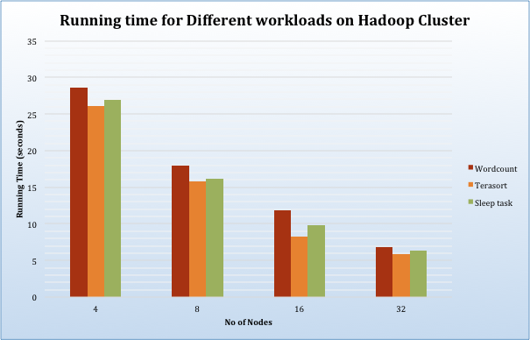
Figure-9 Hadoop benchmarking on different Workloads

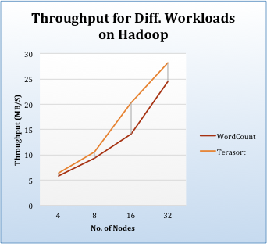
Figure- 10 Throughput for different workloads on Hadoop
- Swift Benchmarking

Swift[16] is an implicitly parallel programming language that allows the writing of scripts that distribute program execution across distributed computing resources, including clusters, clouds, grids, and supercomputers. For benchmarking of swift we performed WordCount on 10 GB of dataset. Figure-11 shows, time taken by different no. of nodes for performing WordCount operation. Figure-12 shows throughput of Swift word count for 10GB dataset on 4 to 32 nodes.

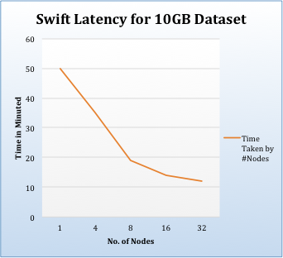
Figure -11 : Swift Latency for word count of 10GB Dataset

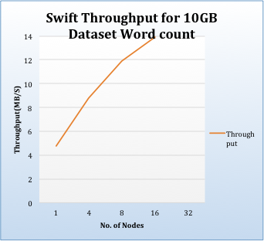
Figure -12 : Swift Throughput for word count of 10GB Dataset

- Charm++ Benchmarking
Charm++[14] is a machine independent parallel programming system. It provides high-level mechanisms and strategies to facilitate the task of developing even highly complex parallel applications.
For charm++ we have executed the sample “queens” program [15]. The time of execution for this program on a single node is 0.61 s. We have configured Cham++ on multiple nodes and ran the same queen program on different scale of nodes. Figure-13 shows throughput on different scale. As shown in figure throughput is increasing with number of nodes.

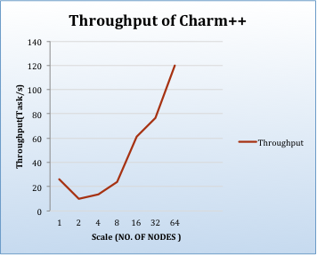
Figure -13 Charm++ Throughput

The reason for decreasing throughput for two nodes is Charm++ create overhead while scheduling on multiple node. With increased in number of nodes overhead dose not increase much that’s why throughput is increased when number of nodes was greater than three.

Related work
Project Myraid[6] is an integration of Mesos[4] and YARN[5], Myraid allows YARN to share resources with Mesos as resource manager of the data center. The advantage of this approach is this actually makes YARN more dynamic, because it gives the resources to YARN that it wants to place where it sees fit. From the Mesos side, if you want to add or remove resources from YARN, it becomes very easy to control dynamically your entire data center.
DETACH and Myraid are bit seemlier in terms of architecture. Myraid uses Mesos as resource manager, while DETACH uses MATRIX as task scheduler for available resources for YARN. In terms of Hadoop performance, DETACH seems more effective than Myraid because, Mesos and YARN both has a centralized architecture that may create performance bottleneck for large-scale applications. In contrast, DETACH uses MATRIX, which has distributed architecture and provides the promising result as the Swift workflow engine. So, our expectation is that DETACH will provide promising results in terms of task utilization and performance.

Conclusion and Future work
The current MapReduce architecture has a centralize task scheduler to dispatch data-intensive application. Work stealing technique can be an essential feature for Hadoop-MapReduce on exascale systems. MTC for exascale MapReduce applications requires distributed-dynamic scheduler at the node level. And MATRIX uses work stealing technique to achieve distributed load balancing.
We proposed distributed load-balancing scheduler of MATRIX for Hadoop-YARN to support exascale computing. In order to achieve high scalability and throughput for MapReduce application, we have designed system-DETACH with an integration of MATRIX and Hadoop-YARN. In this system, we have included MATRIX scheduler at node level of YARN architecture. MATRIX scheduler communicated with each other to achieve work stealing between nodes. Hence, it will improve performance and scalability of Hadoop 2.0.
In this article, we have done benchmarking for Hadoop, MATRIX, Swift and Charm++ to show their comparison in terms of throughput at node scale from 1 to 64. We have done benchmarking for Hadoop and MATRIX to show how our designed system can improve performance and scalability of Hadoop.
Our primary goal for future work is to implement our proposed system – DETACH with integration with Hadoop and MATRIX to support extreme scale computing. Then we will use FusionFS[12] to perform data- aware scheduling [13] as distributed file system. So, it will replace HDFS file system of Hadoop.

References
- "Apache hadoop." [Online]. Available: http://hadoop.apache.org/
- K. Wang, et al. “Paving the Road to Exascale with ManyTask Computing”, Doctoral Showcase, IEEE/ACM Supercomputing/SC 2012.
- Tom White, “Hadoop: The Definitive Guide Storage and Analysis at Internet Scale” , O'Reilly Media ,November 2014
- Ali Ghodsi, Anthony D. Joseph, Randy Katz, Scott Shenker, Ion Stoica, ”Mesos: A Platform for Fine-Grained Resource Sharing in the Data Center” ,UC Berkeley R. Nicole, “Title of paper with only first word capitalized,” J. Name Stand. Abbrev., in press.
- V. K. Vavilapalli, A. C. Murthy, C. Douglas et al., “Apache hadoop yarn: Yet another resource negotiator,” in Proceedings of the 4th annual Symposium on Cloud Computing. ACM, 2013. “Project Myraid”[Online]. https://github.com/mesos/myriad.
- I. Raicu, et. al. “Falkon: A Fast and Light-weight tasK executiON Framework,” IEEE/ACM SC 2007.
- K. Wang, “Distributed Load-Balancing with Adaptive Work Stealing for Many-Task Computing on Billion-Core Systems”.
- T. Li, et al., “ZHT: A light-weight reliable persistent dynamic scalable zero-hop distributed hash table,” in IEEE International Parallel & Distributed Processing Symposium (IPDPS ’13), 2013.
- Iman Sadooghi, Sandeep Palur,Achieving Efficient Distributed Scheduling with Message Queues in the Cloud for Many-Task Computing and High-Performance Computing.
- MATRIX: MAny-Task computing execution fabRIc at eXascales. http://datasys.cs.iit.edu/projects/MATRIX/index.html, 2013.
- H. Goto, Y. Hasegawa, and M. Tanaka, “Efficient Scheduling Focusing on the Duality of MPL Representatives,” Proc. IEEE Symp. Computational Intelligence in Scheduling (SCIS 07), IEEE Press, Dec. 2007, pp. 57-64, doi:10.1109/SCIS.2007.357670.
- Dongfang Zhao and Ioan Raicu. 2012. “Distributed File Systems for Exascale Computing, IEEE/ACM Supercomputing/SC, Utah, USA, 2012.
- Ke Wang and Ioan Raicu. 2014b. Achieving Data-Aware Load Balancing through Distributed Queues and Key/Value Stores. 3rd Greater Chicago Area System Research Workshop (GCASR), Chicago, USA, 2014.
- Charm++ execute program http://charm.cs.illinois.edu/manuals/html/charm++/C.html
- Charm++ Download link http://charm.cs.illinois.edu/software
- Justin M. Wozniak, Timothy G. Armstrong, Michael Wilde, Daniel S. Katz, Ewing Lusk, Ian T. Foster. Swift/T: Large-scale Application
Composition via Distributed-memory Dataflow Processing

